Acquiring Data
Objective
Before you can manipulate and analyze data, first you have to go get it and load it into memory in R. The purpose of this section is to introduce you to some techniques for acquiring data and loading it into data structures in R for further analysis. You will:
- Learn how to open a file on your local machine
- Learn how to retrieve data that is accessible on the web using a URL
- Learn how to retrieve data that is stored in Google Docs (using RCurl)
- Understand why it's important to be aware of data types and data structures as you're acquiring data from different kinds of sources
- Be introduced to helpful utilities like aggregate, paste, an casting between data types
- Learn how to acquire all kinds of government, political, sports, weather, and news data

Before you start, you should:
- Read Section 10.2.1 in Matloff (Reading a Data Frame or Matrix from a File)
- Read Section 10.2.5 in Matloff (Accessing Files on Remote Machines via URLs)

Files on Your Local Machine
One of the most common scenarios you will encounter is that you have your data stored on your local machine, and you need to load it into R so you can manipulate and analyze it. The most common commands you will use to navigate around your machine, find files, and load them are getwd(), setwd(), dir(), read.csv(), read.table(), head() and str().
Central to these commands is the concept of the working directory. Basically, R can only be pointing to one directory on your machine at any given time. If I want to find out which directory R is looking at right now and then examine the contents, I can "get my working directory" by typing getwd() and then find out what's in that directory by typing dir():
> getwd()
[1] "C:/Users/Nicole/Documents"
> dir()
[1] "344-labs-grading-fall2012.doc" "3dtco_v3 (Autosaved).csv"
[3] "Adobe" "AlienFX"
[5] "Alienware TactX" "ALLMYEDGES.txt"
[7] "ALLMYNODES.txt" "Apr10_KayakoInvoice.pdf"
[9] "Avery_Extenci.pdf" "berente-notes.doc"
[11] "Bluetooth Exchange Folder" "Bluetooth Folder"
[13] "CSSBB.pe" "CyberLink"
[15] "desktop.ini" "Downloads"
[17] "EasleyKleinberg_NetworksBook.pdf" "EastPrussiaWar41-45.pdf"
[19] "GitHub" "Grimshaw_Presentation.pdf"
Without changing my working directory, I can access the contents of any one of these files. I notice that there is one CSV file in the top row, so I'll try opening that to see what's inside. I use the read.csv() command because I know it's a CSV file. I'm also going to store my entire file in a variable that I will call temp (short for "temporary" because I'm probably not going to use this variable after I poke around the file a little bit). After I read the file, I'll take a look at the first six lines of the file using head and then ask R what data structures it has assigned to each variable using str:
> temp <- read.csv("3dtco_v3 (Autosaved).csv")
> head(temp)
group subsystem product priority reltco satis customiz
1 1 Database Oracle Highest 0.9985 0.978 0.000
2 1 Database Oracle Moderate 0.9997 0.933 0.000
3 1 Database Oracle Lowest 1.0000 0.927 0.000
4 2 Database IBM DB2 Highest 0.5739 0.782 0.196
5 2 Database IBM DB2 Moderate 0.5752 0.760 0.173
6 2 Database IBM DB2 Lowest 0.5754 0.768 0.159
> str(temp)
'data.frame': 39 obs. of 7 variables:
$ group : int 1 1 1 2 2 2 3 3 3 4 ...
$ subsystem: Factor w/ 4 levels "AM/OSM","CMES",..: 3 3 3 3 3 3 2 2 2 2 ...
$ product : Factor w/ 13 levels "IBM DB2","IBM Maximo",..: 10 10 10 1 1 1 3 3 3 11 ...
$ priority : Factor w/ 3 levels "Highest","Lowest",..: 1 3 2 1 3 2 1 3 2 1 ...
$ reltco : num 0.999 1 1 0.574 0.575 ...
$ satis : num 0.978 0.933 0.927 0.782 0.76 0.768 0.9 0.816 0.754 0.7 ...
$ customiz : num 0 0 0 0.196 0.173 0.159 0 0.084 0.146 0.2 ...

The head and str commands tell me complementary information. For example, I know from str that there are 7 variables, and I know from head that the names of these variables are group, subsystem, product, priority, reltco, satis, and customiz. I can also find out the variable names from str, but str gives me even more information - it tells me the data type for each of the variables. Let's say we want to find the average reltco for each subsystem. (This stands for "relative total cost of ownership." It's the total cost of ownership of a product relative to other comparable choices, which allows for more accurate within-group comparisons.) The subsystem variable is a factor with 4 levels, each of which refers to a software subsystem at a major organization. AM/OSM refers to an asset management system, where information is stored to track equipment and computers. CMES refers to an internal message bus, which is basically an application that helps other software packages communicate with one another. DPMS is a data processing management system, and Database is a database. Fortunately, reltco is a number, and we can compute averages of numbers. But how do we split up our data set in terms of which subsystem each row is associated with? In R, there are many different ways to do things, so don't think that this is the only way to do it... but I like using aggregate like this:
> aggregate(reltco~subsystem, data=temp, FUN=mean)
subsystem reltco
1 AM/OSM 0.5476667
2 CMES 0.6475000
3 Database 0.7871167
4 DPMS 0.6330000
How you say this in English is: "I want to aggregate the reltco variable by subsystem, from the data set named temp, using the mean function." I underlined each of the three arguments that are being passed to the aggregate command. The first one tells R to split up the reltco variable into groups according to the value of subsystem. The second argument specifies that these values will come from the data set called temp, and the third argument says to apply the function mean to the groups.
You can use all sorts of different functions in aggregate. Here are a few examples. Notice how some of the functions operate on the complete list of reltco values, whereas other functions operate on the aggregations themselves. The first example below simply lists the contents of the aggregated data set. The second example computes the length of each list that is returned (meaning, it will tell you how many data points are in each aggregation). The third example adds up each of the lists, using the sum function. The fourth example tells us whether each value is missing (or not) using is.na (which stands for "is not available"). This would be a good way to figure out whether there is some pattern in your missing data.
> aggregate(reltco~subsystem, data=temp, FUN=list)
subsystem reltco
1 AM/OSM 1.0000, 1.0000, 1.0000, 0.5746, 0.5746, 0.5746, 0.0684, 0.0684, 0.0684
2 CMES 0.90, 0.96, 1.00, 0.67, 0.72, 0.80, 0.48, 0.55, 0.60, 0.32, 0.37, 0.40
3 Database 0.9985, 0.9997, 1.0000, 0.5739, 0.5752, 0.5754
4 DPMS 1.000, 1.000, 1.000, 0.760, 0.776, 0.800, 0.520, 0.540, 0.600, 0.200, 0.200, 0.200
> aggregate(reltco~subsystem, data=temp, FUN=length)
subsystem reltco
1 AM/OSM 9
2 CMES 12
3 Database 6
4 DPMS 12
> aggregate(reltco~subsystem, data=temp, FUN=sum)
subsystem reltco
1 AM/OSM 4.9290
2 CMES 7.7700
3 Database 4.7227
4 DPMS 7.5960
> aggregate(reltco~subsystem, data=temp, FUN=is.na)
subsystem reltco
1 AM/OSM FALSE, FALSE, FALSE, FALSE, FALSE, FALSE, FALSE, FALSE, FALSE
2 CMES FALSE, FALSE, FALSE, FALSE, FALSE, FALSE, FALSE, FALSE, FALSE, FALSE, FALSE, FALSE
3 Database FALSE, FALSE, FALSE, FALSE, FALSE, FALSE
4 DPMS FALSE, FALSE, FALSE, FALSE, FALSE, FALSE, FALSE, FALSE, FALSE, FALSE, FALSE, FALSE

CSV Files on the Web
There are many data files stored on the web, and fortunately these are easily accessible from within the R environment if you know the URL where the data is stored. In Section 10.2.5 of Matloff, there is a quick example that shows how to access some data that is in the machine learning repository at the University of California Irvine (UCI). Before we access the data within R, just cut and paste this URL into the address window of your web browser to browse the contents:
http://archive.ics.uci.edu/ml/machine-learning-databases/echocardiogram/echocardiogram.data
It looks a lot like a CSV file. Here are the first 10 rows:
11,0,71,0,0.260,9,4.600,14,1,1,name,1,0
19,0,72,0,0.380,6,4.100,14,1.700,0.588,name,1,0
16,0,55,0,0.260,4,3.420,14,1,1,name,1,0
57,0,60,0,0.253,12.062,4.603,16,1.450,0.788,name,1,0
19,1,57,0,0.160,22,5.750,18,2.250,0.571,name,1,0
26,0,68,0,0.260,5,4.310,12,1,0.857,name,1,0
13,0,62,0,0.230,31,5.430,22.5,1.875,0.857,name,1,0
50,0,60,0,0.330,8,5.250,14,1,1,name,1,0
19,0,46,0,0.340,0,5.090,16,1.140,1.003,name,1,0
25,0,54,0,0.140,13,4.490,15.5,1.190,0.930,name,1,0

We can read the contents of the file into R as if it were a CSV file, following the code in Matloff. But then, we will also use the str command to examine the structure of the data, and then the head command to look at some of the values of the variables:
> uci <- "http://archive.ics.uci.edu/ml/machine-learning-databases/"
> uci <- paste(uci,"echocardiogram/echocardiogram.data",sep="")
> ecc <- read.csv(uci)
> str(ecc)
'data.frame': 132 obs. of 13 variables:
$ X11 : Factor w/ 57 levels "",".03",".25",..: 18 16 54 18 27 14 50 18...
$ X0 : Factor w/ 4 levels "","?","0","1": 3 3 3 4 3 3 3 3 3 4 ...
$ X71 : Factor w/ 40 levels "","?","35","46",..: 30 12 17 14 26 19 17 4 ...
$ X0.1 : int 0 0 0 0 0 0 0 0 0 0 ...
$ X0.260: Factor w/ 74 levels "","?","0.010",..: 65 50 47 26 50 42 59 60 ...
$ X9 : Factor w/ 93 levels "","?","0","10",..: 69 57 13 46 62 56 79 3 ...
$ X4.600: Factor w/ 106 levels "","?","2.32",..: 25 6 54 92 38 85 76 70 ...
$ X14 : Factor w/ 48 levels "","?","10","10.5",..: 16 16 21 27 8 36 16 ...
$ X1 : Factor w/ 67 levels "","?","1","1.04",..: 48 3 37 60 3 52 3 11 ...
$ X1.1 : Factor w/ 32 levels "","?","0.140",..: 14 30 25 13 27 27 30 31 ...
$ name : Factor w/ 3 levels "","?","name": 3 3 3 3 3 3 3 3 3 3 ...
$ X1.2 : Factor w/ 5 levels "","?","1","2",..: 3 3 3 3 3 3 3 3 3 3 ...
$ X0.2 : Factor w/ 5 levels "","?","0","1",..: 3 3 3 3 3 3 3 3 3 4 ...
> head(ecc)
X11 X0 X71 X0.1 X0.260 X9 X4.600 X14 X1 X1.1 name X1.2 X0.2
1 19 0 72 0 0.380 6 4.100 14 1.700 0.588 name 1 0
2 16 0 55 0 0.260 4 3.420 14 1 1 name 1 0
3 57 0 60 0 0.253 12.062 4.603 16 1.450 0.788 name 1 0
4 19 1 57 0 0.160 22 5.750 18 2.250 0.571 name 1 0
5 26 0 68 0 0.260 5 4.310 12 1 0.857 name 1 0
6 13 0 62 0 0.230 31 5.430 22.5 1.875 0.857 name 1 0

This is a data frame with 132 rows (observations), each containing 13 variables. Most of the variables are factors, but one is an integer (int). However, we know that the third column (labeled X71) is the age of each of the people who has received an echocardiogram in this sample. What if we want to figure out the mean age of people in this sample?
> mean(ecc$X71)
[1] NA
Warning message:
In mean.default(ecc$X71) : argument is not numeric or logical: returning NA
We can't do it. Why? Because we are trying to compute an average value for a factor, which is a categorical variable. It's almost like trying to calculate the average color of M&Ms in one bag. But we know that there are ages stored in that column, and we know that we should be able to compute an average. What we can do is cast these factors to numerical values to compute the mean:
> mean(as.numeric(ecc$X71))
[1] 19.23485

We're doing exactly the same thing as we did in the last statement, but now we're asking R to treat the values for the variable X71 in the ecc data set as numbers. This is read as "give me the mean of the values inside the variable X71, from the data set ecc, and treat them as numbers."

Collect Your Own Data: Google Forms and Google Spreadsheets
Many people are now storing data in the cloud, for example, in a Google Spreadsheet. This is a useful system to be familiar with because multiple people can edit the same document, and see each others' changes in real time. So if you are part of a research or analysis team, everyone can contribute to filling in the data, and everyone can access it in their R analysis environment. Furthermore, you can use Google Forms to automatically populate a Google Spreadsheet to analyze!
Creating a Google Form is ridiculously easy, however, you must have a Google account before you connect to Google Drive at http://drive.google.com and begin. Once you're in Drive, click on the red "Create" button in the top left corner of your screen, and select "Form" in the dropdown list that appears. You will be prompted to create different types of questions. When you are done, click "Done". Here is the quick test form I just created:
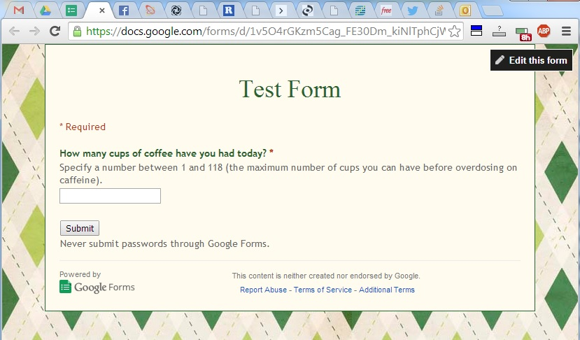
Figure X.1: You can create Google Forms that automatically populate Google Spreadsheets.
When you click "Send Form" you will see a text box containing a URL under "Link to Share" -- that's going to be the link you send to your respondents to collect data. When you click "View Responses" in the top menu bar (circled in Figure X.2), it will bring you to the Google Spreadsheet where your responses will automatically show up. This is the URL you should copy and paste so you can access your data in R using RCurl (we'll step through that process next!)
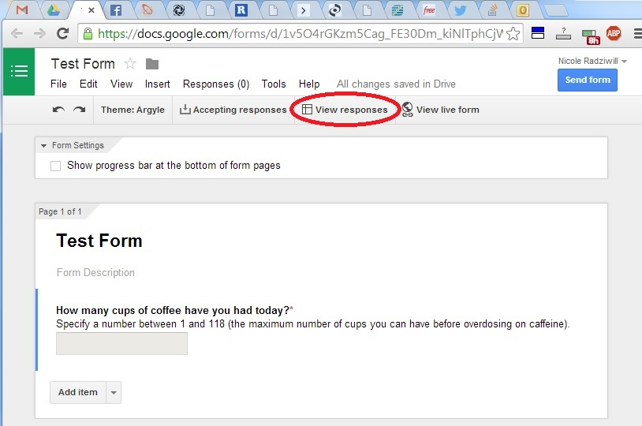
Figure X.2: Here's how you find the URL of the Google Spreadsheet where responses are stored.

Analyze Your Own Data: Google Spreadsheets and RCurl
Buried within the list of CRAN packages available to download and utilize in R is a package called RCurl. One of the functions RCurl allows you to do is request the contents of a URL, process the contents in a way that lets you look at it, and ultimately stores the contents into a variable in R. To demonstrate this, let’s walk through the example.
First, open up an R environment and navigate to the dropdown menu titled Packages (Windows) or Packages & Data (Mac). Click on Install Package(s)… (Windows) or Package Installer (Mac). In the list of libraries, look for a library titled RCurl. Select it and download it. (If you are a Mac user, remember to install RCurl’s dependencies by checking the Install Dependencies box.) Now that RCurl is downloaded on your computer, load it into R like this:
library("RCurl")
If you get an error, check to make sure your quotation marks are in the right place (and closed), and also be sure you are capitalizing both the R and C in RCurl.
For this example, we will use another Google Spreadsheet that already has data loaded into it. This is the points spreadsheet for a class I taught in a previous semester. This is a really long URL so the first thing we will do is piece it together using the paste command. (There is no value in doing this OTHER than being able to type the URL in using smaller pieces on multiple lines. Sometimes this is easier than trying to type a huge, long URL into R and not being able to see the whole thing.)
url <- "https://docs.google.com/spreadsheet/pub?"
url <- paste(url,"key=0AoVN55HxlNvKdHh1S2sxQzRkSHlzLW1kVjREVFh4Z2c&single=true",sep="")
url <- paste(url,"&gid=0&output=csv",sep="")

Once you have the URL set up as a variable, you can use it to open the Google Spreadsheet and make sure that the data is in the format you desire. We load the contents of our spreadsheet into a variable that we decide to call spreadsheet.data using the getURL command, and add in the argument ssl.verifypeer=FALSE just in case there are permission problems that come from using the secure HTTP protocol, https.

> spreadsheet.data <- getURL(url,ssl.verifypeer=FALSE)
> str(spreadsheet.data)
chr "who,what,when,points\nesquildf,RNG Exponential,1/27/2014,2\nesquildf,RNG Weibull,1/27/2014,1\nesquildf,RNG Triangular,1/27/2014"| __truncated__

But here's the problem: all of our data came in as ONE character string, so we will find it impossible to work with unless we create a data frame, somehow. Notice that it looks kind of like a CSV file, and the first line is indeed a header containing our variable names: who, what, when, points. But then you'll notice there are lots of "\n" in there too, which is the code for "line feed" (indicating the end of a line in your data file). We need to 1) split that looooong character string into individual lines, separated by the \n characters that we see, and 2) then split those lines into individual values that correspond to each of our variables.
We can accomplish the first part using textConnection, and the second part using read.csv - and lucky for us, this automatically gives us a data frame that we can use:
> points <- read.csv(textConnection(spreadsheet.data))
> str(points)
'data.frame': 422 obs. of 4 variables:
$ who : Factor w/ 47 levels "ander3ad","ayersjc",..: 12 12 12 12 37 37 ...
$ what : Factor w/ 91 levels "ABM Exploration",..: 78 81 80 72 78 81 80 ...
$ when : Factor w/ 30 levels "1/27/2014","2/1/2014",..: 1 1 1 1 1 1 1 1 ...
$ points: int 2 1 1 2 2 1 1 2 2 1 ...
> head(points)
who what when points
1 esquildf RNG Exponential 1/27/2014 2
2 esquildf RNG Weibull 1/27/2014 1
3 esquildf RNG Triangular 1/27/2014 1
4 esquildf Output Analysis 1/27/2014 2
5 roseph RNG Exponential 1/27/2014 2
6 roseph RNG Weibull 1/27/2014 1

How would you figure out how many points roseph acquired over the course of the semester?

Accessing Real Repositories: APIs, JSON, and rjson
Often, data is not stored on the web but is accessible from the web. You just have to know how to get it, and how to deal with the data format that you are served. It is not uncommon for organizations to offer access to their databases if you know a little programming. They will publish Application Programming Interfaces (or APIs) that provide you with objects and methods to get to their data. Two common data formats are eXtensible Markup Language (XML) and JavaScript Object Notation (JSON). This section covers the JSON format and how to obtain data in JSON format through the R console, using the rjson package. (You can explore XML on your own, if you like.) Be sure to install rjson first!
This example uses the Weather Underground API at http://www.wunderground.com/weather/api/. To use it, you first have to register to gain access and get what's called an "API Key". Services like this often want to make sure that you are a real human, and not just a bot who will overload their system with requests for information. Where it says KEY is where I used my personal API key:
> json.file <- "http://api.wunderground.com/api/KEY/conditions/q/CA/San_Francisco.json"
> json.data <- fromJSON(paste(readLines(json.file), collapse=""))
> str(json.data)
List of 2
$ response :List of 3
..$ version : chr "0.1"
..$ termsofService: chr "http://www.wunderground.com/weather/api/d/terms.html"
..$ features :List of 1
.. ..$ conditions: num 1
$ current_observation:List of 56
..$ image :List of 3
.. ..$ url : chr "http://icons.wxug.com/graphics/wu2/logo_130x80.png"
.. ..$ title: chr "Weather Underground"
.. ..$ link : chr "http://www.wunderground.com"
..$ display_location :List of 12
.. ..$ full : chr "San Francisco, CA"
.. ..$ city : chr "San Francisco"
.. ..$ state : chr "CA"
.. ..$ state_name : chr "California"
.. ..$ country : chr "US"
.. ..$ country_iso3166: chr "US"
.. ..$ zip : chr "94101"
.. ..$ magic : chr "1"
.. ..$ wmo : chr "99999"
.. ..$ latitude : chr "37.77500916"
.. ..$ longitude : chr "-122.41825867"
.. ..$ elevation : chr "47.00000000"
..$ observation_location :List of 8
.. ..$ full : chr "NEMA, San Francisco, California"
.. ..$ city : chr "NEMA, San Francisco"
.. ..$ state : chr "California"
The fromJSON command reads input in JSON format and automatically converts it into a data structure that is accessible from within R. This is a complicated data structure that consists of lists embedded within other lists! Here are some examples of 1) how to access the variables within this data structure created from the JSON data that we acquired, and 2) how to determine the data type for each variable:
> json.data$current_observation$display_location$latitude
[1] "37.77500916"
> is.numeric(json.data$current_observation$display_location$latitude)
[1] FALSE
> is.character(json.data$current_observation$display_location$latitude)
[1] TRUE
> json.data$current_observation$observation_time
[1] "Last Updated on August 16, 12:35 PM PDT"
> is.character(json.data$current_observation$observation_time)
[1] TRUE
> json.data$current_observation$temperature_string
[1] "65.8 F (18.8 C)"
> is.character(json.data$current_observation$temperature_string)
[1] TRUE
> json.data$current_observation$temp_f
[1] 65.8
> is.character(json.data$current_observation$temp_f)
[1] FALSE
> is.numeric(json.data$current_observation$temp_f)
[1] TRUE

Another very useful capability is to compress individual pieces of the JSON-formatted data into smaller data structures that you can manipulate more easily. For example, if we want to capture only the 8 elements of json.data$current_observation$observation_location into a list, we can do this:
> obs.location <- rep(NA,length(json.data$current_observation$observation_location))
> for (n in 1:length(json.data$current_observation$observation_location)) {
+ obs.location[n] <- json.data$current_observation$observation_location[[n]]
+ }
> obs.location
[1] "NEMA, San Francisco, California" "NEMA, San Francisco"
[3] "California" "US"
[5] "US" "37.776077"
[7] "-122.417542" "102 ft"

Now you can refer to individual elements of obs.location - for example, the station elevation can be directly retrieved by calling the last element of the list:
> obs.location[8]
[1] "102 ft"
Note that you can also cut and paste the entire API call into the address box in your browser. As long as you've typed it in correctly and used a valid API key, you should see the text of the entire JSON object that's been extracted from the Weather Underground database. This is a great way to test and see whether your API call is working, if your R code using fromJSON is giving you an error.
Lots of data repositories have APIs that allow you to retrieve data in JSON format, and using the rjson package and the fromJSON command, you should be able to bring any of this data into R for further analysis. Here are some repositories that might have useful information for you to try acquiring.
- Votes, Membership Lists, Bills, and Schedules from the US Congress: http://developer.nytimes.com/docs/read/congress_api/congress_api_examples
- Opensecrets.org (Center for Responsive Politics): https://www.opensecrets.org/resources/create/api_doc.php
- Federal Communications Commission, TV Station Profiles and Public Inspection Files: https://stations.fcc.gov/developer/
- New York Times API: http://developer.nytimes.com/docs
- There are more examples of government, political, social, weather, sports, and news APIS at http://blog.visual.ly/data-sources/

Get Points!
To demonstrate the knowledge that you have gained from this exercise, you can do one or both of the following:
1) create a new data acquisition form using Google Forms,
2) get several of your classmates to fill it out and provide you with data, and
3) load the data into R and compute one interesting metric based on the data you have gathered

and/or
1) register for developer access to an API key (e.g. at Weather Underground or OpenSecrets)
2) acquire some interesting JSON data and store it in a relevant format for your analysis, then
3) compute one thing that's interesting from your data

Be sure to keep a listing of all of your code (and the data files you used) to store in your GitHub portfolio.

Now What?
You now have the background and experience to try:
- Playing with any of the data files at http://archive.ics.uci.edu/ml/machine-learning-databases/
- Exploring conditional formatting of Google Spreadsheets... you can do cool things like turn boxes different colors based on the data in the cells, or mathematical operations on that data. There are tons of opportunities here. Get started with these examples:
  - http://thejournal.com/articles/2014/03/19/extending-conditional-formatting-in-google-sheets-using-dynamic-date-calls.aspx
  - See the most recent YouTube videos on conditional formatting by going to https://www.youtube.com/results?search_query=conditional+formatting+google+docs&filters=year&search_sort=video_avg_rating

